Summer Web Design: Day 6

What is CSS?

* **CSS** stands for **C**ascading **S**tyle **S**heets
* Styles define **how to display** HTML elements
* Styles were added to HTML 4.0 **to solve a problem**
* **External Style Sheets** can save a lot of work
* External Style Sheets are stored in **CSS files**

One web page looks very different with different CSS: [www.w3schools.com/css/demo_default.htm](http://www.w3schools.com/css/demo_default.htm)

Even more examples: <http://csszengarden.com/>

A CSS rule set consists of a selector and a declaration block:

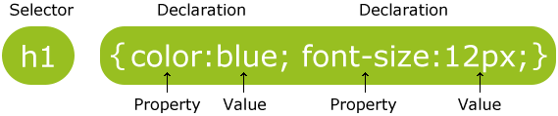

Exercise 1:

a. Create a new document and name it mystyle.css.

b. Open your webpage and add a line in the <HEAD>:

<link rel="stylesheet" type="text/css" href="mystyle.css">

c. Save this web page as day6.html.

d. Remove you style from each tag and div.

e. Choose one of the styles found at [www.w3schools.com/css/demo_default.htm](http://www.w3schools.com/css/demo_default.htm). Carefully copy one of the 4 styles and paste it into mystyle.css.

f. Test day6.html.

g. Your menu HTML should be changed so that you use the new menu style. Also use the sidebar.

h. Test your page.

i. Change the css to another one of the examples.

Exercise 2:

a. Choose one of the cool things at:

<http://tutorialzine.com/2013/10/12-awesome-css3-features-you-can-finally-use/>

<http://www.w3schools.com/css/css3_intro.asp>

b. Sign up for the presentation you will give.

c. Create a new web page: fancy.html along with a stlyesheet: fancy.css. Get your style working. Practice a presentation for they class that is at least 3 minutes long. When requested, present your cool feature to the class.

Project:

a. Create a css sheet for your web page and upload it.

b. Include a fancy feature.

c. Have the person next to you give you feedback:

Name:_____________________________

Is the written content interesting? Did reading it bring up questions about the person?

Do the pictures or videos support the content?

Is the style appealing?

Do they have clear navigation to break up the page into meaningful pieces?