**Day 10**

**Exercise 1:**

a. Download and Open ElevatorInputValidation. Read through the code outline that we covered in class. Notice the messages to the user to determine how to complete the if statements for the three options (which makes this an if, else if, else structure

b. Test to for user entering floor as 13, test for user entering a floor less than 1 or greater than 18, complete the code in the else to test if the floor entered is 14 or higher

c. Have your neighbor test your code.

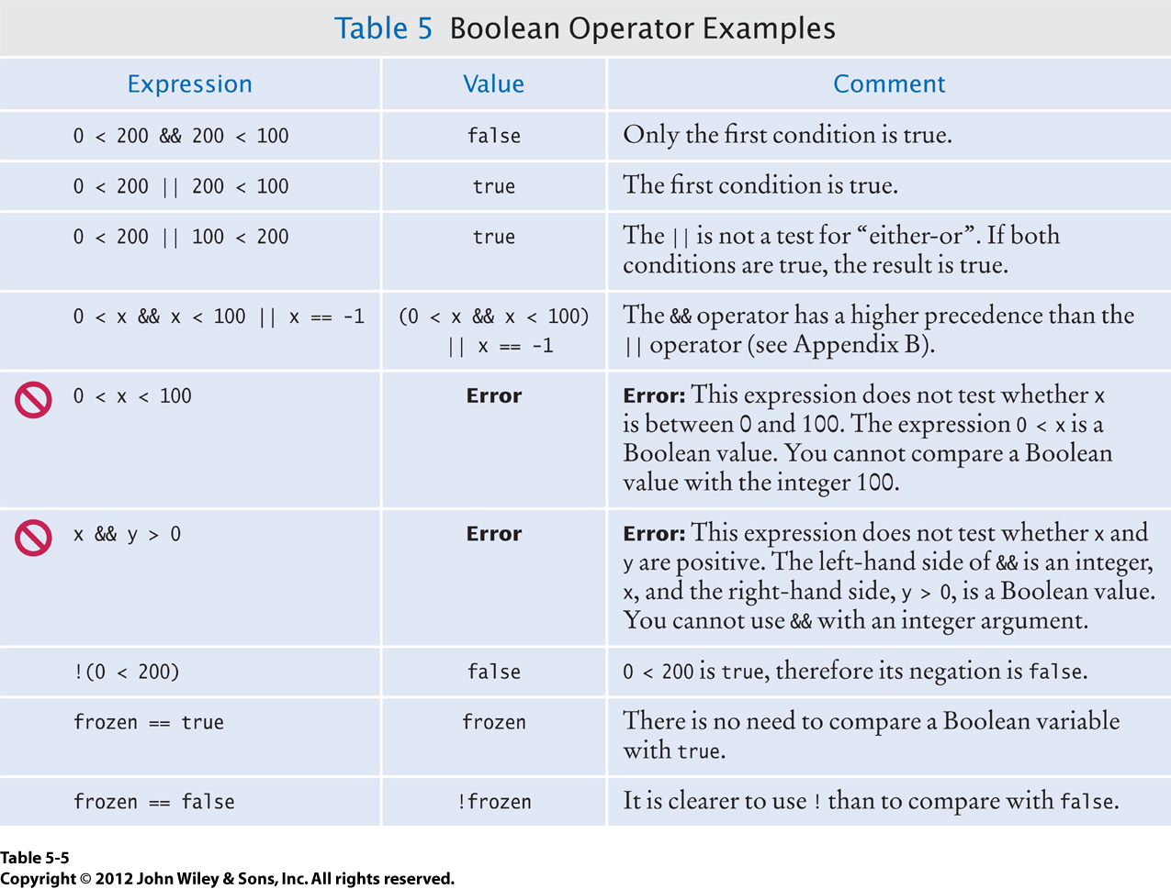**Exercise 2:** Complete the table

**Exercise 3:**

a. Download and open EqualStrings.

b. Change the condition on the if statement to properly test the two Strings.

c. Test your program

**Exercise 4:**

a. Download Copying Rectangles into a Day 10 folder (so that it odesn’t conflict with thet Day 3 Copying Rectangles)

b. Follow the instructions from class and in the Rectangle class to write the equals() method.

c. Test the method by running copyingRectangles.

**Exercise 5:**

a. Write the equals() method in the Day class. Follow the design plan from class and the instructions in the comments in the class code.

b. Edit the tester to call the method you wrote rather than the == operator.

c. Test your code.

**Exercise 6:**

a. Open the vowels project. Edit the Word class to test for vowels and consonants.

b. Test your code.

**Optional:**

Remember the game “Rock, Paper, Scissors”? It is a two-player game in which each person simultaneously chooses either rock, paper, or scissors. Rock beats scissors but loses to paper, paper beats rock but loses to scissors, and scissors beats paper but loses to rock. The following code prompts player 1 and player 2 to each enter a string: rock, paper, or scissors. Finish the code by adding nested if statements to appropriately report “Player 1 wins”, “Player 2 wins”, or “It is a tie.”

import java.util.Scanner;

public class RockPaperScissors

{

public static void main(String[] args)

{

Scanner scan = new Scanner(System.in);

System.out.println("Player 1: Choose rock, scissors, or paper:");

String player1 = scan.next().toLowerCase();

System.out.println("Player 2: Choose rock, scissors, or paper:");

String player2 = scan.next().toLowerCase();

(your code goes here…)

(write the nested iff statements before writing code)

}

}